Travel Insurance Prediction

1 Introduction

* 1. Overview

The purpose of a travel insurance prediction dataset is to empower the insurance industry with data-driven insights and tools to enhance risk assessment, underwriting, and claims processing within the context of travel insurance. By compiling historical data on travellers , their trips, and related events, such as claims and incidents, this dataset enables the development of predictive models. These models, powered by machine learning and analytics, serve multiple vital functions, including determining appropriate premium rates, identifying high-risk cases, optimizing pricing strategies, streamlining claims processing, and enhancing fraud detection. Ultimately, a travel insurance prediction dataset helps insurance companies make more informed and efficient decisions, leading to better service for customers, tailored insurance products, and improved overall risk management in the travel insurance sector.

* 1. **PURPOSE**

The purpose of a travel insurance prediction dataset is multifaceted and essential for the travel insurance industry, encompassing a range of functions that leverage historical data to enhance various aspects of insurance operations .First and foremost, it plays a pivotal role in risk assessment . Travel insurers need to understand the probabilities of different events occurring during a trip, such as trip cancellations, medical emergencies, lost luggage, or flight delays. By analyzing past data, insurers can gauge the likelihood of these events, allowing them to make informed decisions regarding coverage and pricing. Additionally, these datasets support underwriting, which involves assessing the risk profile of travellers and deciding appropriate premium rates and coverage. The dataset enables insurance companies to match customers with policies that best fit their risk profiles, ensuring a fair and competitive offering. Furthermore, the dataset is crucial for claims. Processing efficiency Predictive models can automate the evaluation of claims, allowing for quicker processing of claims with lower predicted risks and more in-depth scrutiny for those with higher predicted risks. This efficiency benefits both insurance companies and customers. A vital aspect is fraud detection. Insurance companies can use predictive models to identify potentially fraudulent claims by comparing actual claim data to predicted outcomes. Any deviations from the expected patterns can signal fraudulent activity, allowing insurers to investigate further . Moreover the dataset is instrumental in customer profiling. By analyzing the dataset, insurance providers can segment their customer base based on their travel habits and preferences. This segmentation enables the creation of personalized insurance offerings and targeted marketing strategies, which, in turn, leads to improved customer satisfaction and business performance. Furthermore, product development benefits from these datasets. The insights gained from predictive modelling can inform the development of new insurance products or the modification of existing ones to better meet the needs of travellers . This results in more comprehensive and customer-centric insurance offerings. In the realm of actual analysis, insurers use the dataset to refine their mathematical models for insurance pricing and reserve setting. Accurate prediction data enhances actuarial calculations, improving the long-term financial stability of insurance companies. These datasets also play a vital role in regularity compliance. Insurance providers must adhere to various regulations and reporting requirements.

1. Literature Survey
   1. Existing Problems

While travel insurance prediction data offers various benefits and applications, there are several existing challenges and problems associated with its use. Some of the key issues include:

1. Data Privacy and Security: Collecting and handling sensitive personal information for predictive modelling raises privacy concerns. Ensuring data security and compliance with data protection regulations, such as GDPR, is crucial but can be challenging for insurers.
2. Data Quality: The quality and accuracy of the data used for prediction can be a significant issue. Inaccurate or incomplete data can lead to flawed predictions and underwriting decisions.
3. Bias and Discrimination: Predictive models can inadvertently incorporate bias from historical data. This can result in discriminatory practices that disproportionately affect certain groups, raising ethical and legal concerns.
4. Over-Reliance on Historical Data: Predictive models primarily rely on historical data, making them less effective in predicting unforeseen events or changes in travel patterns, like pandemics or natural disasters.
5. Model Interpretability: Many predictive models are complex and difficult to interpret. This can lead to a lack of transparency, making it challenging for consumers to understand how decisions are made and undermining trust.
6. Inadequate Coverage: Predictive models may overlook or inadequately cover certain types of risks, leading to gaps in coverage for travellers. Uncommon or evolving risks may not be adequately addressed.
7. Regulatory Challenges: The travel insurance industry is subject to various national and international regulations, which can vary significantly. Compliance with these regulations while using predictive data can be complex and may require considerable resources.
8. Scalability: Developing and maintaining predictive models can be resource-intensive, especially for smaller insurance providers. Scalability challenges can limit the adoption of predictive analytics in the industry.
9. Customer Mistrust: Travelers may have concerns about how their data is being used and whether predictive models are truly in their best interests. This can lead to a lack of trust in insurance companies.
10. Resistance to Change: The insurance industry has a history of tradition and conservative practices. Implementing predictive analytics and changing established processes can face resistance from within the industry.
11. Cultural and Behavioural Factors: Human behaviour can be unpredictable, and cultural factors may influence travel decisions and claims patterns. Predictive models may struggle to account for these factors accurately.
12. Forecasting Uncertainty: Predictive models provide probabilities and forecasts, but they cannot predict the future with certainty. Overreliance on predictions can lead to misjudgment and financial
    1. Proposed Solutions

Proposing solutions for travel insurance prediction data involves addressing the challenges and opportunities associated with developing predictive models for the travel insurance industry. Here are some proposed solutions:

1. **Data Quality Improvement:** Ensure data is accurate, consistent, and up-to-date. Implement data validation checks and data cleaning processes to address issues like missing values and outliers. Additionally, regular audits and data quality assessments can help maintain data integrity.
2. **Feature Engineering:** Carefully select and engineer relevant features that have a significant impact on the prediction task. Incorporate destination-specific factors, health risk indicators, and historical travel behaviour to create a comprehensive feature set.
3. **Privacy Preservation:** Given the sensitive nature of personal and medical data involved in travel insurance, robust data anonymization and encryption techniques should be used to protect customer privacy. Compliance with data protection regulations, such as GDPR, is essential.
4. **Bias Mitigation:** Be vigilant about potential biases in the data, especially when historical data might reflect discriminatory practices. Implement fairness-aware machine learning techniques to ensure that predictive models do not discriminate against certain groups.
5. **Regular Model Evaluation:** Continuously assess the performance of predictive models to ensure their accuracy and reliability. Use metrics like accuracy, precision, recall, and F1-score to gauge model effectiveness. Models should be fine-tuned and updated as necessary.
6. **Data Transparency:** Maintain transparency in data sources, data collection methods, and modelling techniques. Open communication and documentation regarding data and model use help build trust with stakeholders and regulatory bodies.
7. **Collaboration with Industry Experts:** Collaborate with experts in the travel insurance industry to better understand the nuances of the sector, including travel risks, regulatory requirements, and customer preferences. Their insights can improve the quality and relevance of predictive models.
8. **Ethical Considerations:** Prioritize ethical considerations throughout the process, from data collection to model deployment. Establish guidelines and principles to ensure the responsible use of predictive models in the insurance industry.
9. **Customer Education:** Educate customers about how their data is used and the benefits of predictive modelling in improving insurance services. Transparency and customer engagement can enhance trust and acceptance.
10. **Regulatory Compliance:** Stay updated on relevant data protection and insurance regulations and ensure full compliance. Collaborate with legal experts to navigate the regulatory landscape.
11. **Cross-Validation and Validation Techniques:** Employ robust cross-validation methods to assess model performance and generalizability. Techniques like k-fold cross-validation can help in validating models effectively.
12. **Continual Monitoring:** Establish a system for ongoing monitoring of the predictive models in real-world scenarios. Continuous model monitoring can detect performance degradation and any shifts in the data distribution.

3. Theoritical Analysis

3.1 Block Diagram

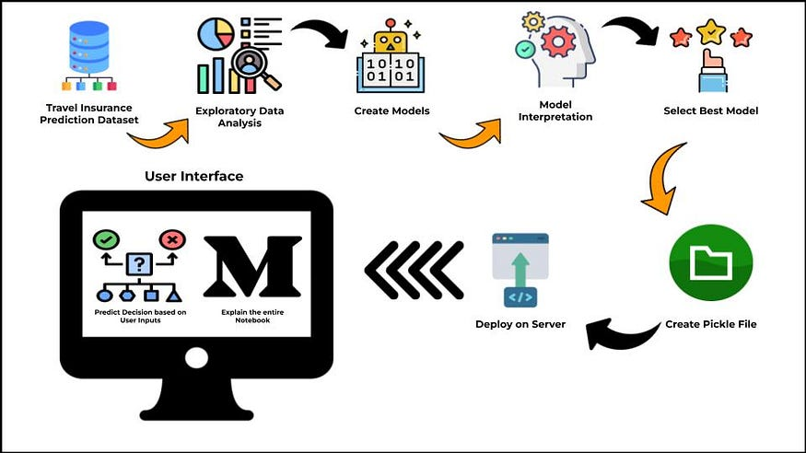

4. Advantages and Disadvantages

4.1 Advantages

1. Risk Assessment: Predictive data allows insurance companies to assess the risk associated with insuring a particular traveller or trip. By analyzing historical data, such as travel patterns, destination choices, and past claims, insurers can better estimate the likelihood of future claims. This helps in setting appropriate premium rates and coverage limits.
2. Personalized Pricing: Travel insurance providers can offer more personalized pricing to travellers based on their individual risk profiles. Those with lower risk factors may receive lower premiums, while higher-risk travellers may be charged more. This benefits travellers by potentially reducing their insurance costs.
3. Fraud Detection: Predictive data models can be used to detect fraudulent claims and activities. Insurance companies can identify suspicious patterns or anomalies in claims data, helping to reduce fraudulent claims and maintain the integrity of the insurance system.
4. Claims Processing Efficiency: Predictive analytics can improve claims processing by automating routine tasks and identifying valid claims more quickly. This speeds up the claims settlement process and enhances the overall customer experience.
5. Product Customization: Predictive data can inform the development of new insurance products and policies tailored to specific customer segments or types of travel. For example, insurers can offer specialized coverage for adventure travellers, business travellers, or senior citizens based on predictive insights.
6. Improved Customer Experience: Predictive analytics can help insurers provide a more seamless and user-friendly experience for travellers. This includes offering travel tips, safety recommendations, and real-time alerts based on the traveller's destination and profile.
7. Risk Mitigation: Insurance companies can proactively engage with travelers to provide safety information or mitigate risks during their trips. For example, they can offer information about local healthcare facilities, travel advisories, or weather alerts.
8. Resource Allocation: Predictive data can assist insurance companies in allocating resources more efficiently. For instance, they can better plan for claims processing staff, underwriting, and customer service based on anticipated demand.
9. Competitive Advantage: Insurers who effectively use predictive data to offer more accurate pricing and improved customer experiences can gain a competitive advantage in the market. Travelers are likely to choose insurers that offer better rates and service.
10. Loss Ratio Improvement: By better understanding the factors contributing to claims, insurance companies can make data-driven decisions to minimize losses and optimize their underwriting and risk management strategies.

4.2 Disadvantages

1. Privacy Concerns: The collection and use of predictive data may raise privacy issues, as it often involves gathering and analyzing personal information about travellers. Customers may be concerned about the extent to which their data is used and shared.
2. Data Security: Safeguarding predictive data is crucial to protect against data breaches and cyberattacks. The storage and transmission of sensitive customer information carry risks, and insurance companies must invest in robust cybersecurity measures.
3. Bias and Discrimination: Predictive models can inadvertently incorporate bias if historical data reflects discriminatory or biased practices. This can lead to unfair treatment of certain groups of travellers, such as those from particular demographics or regions.
4. Inaccuracies in Predictions: Predictive models are not infallible, and their accuracy depends on the quality of data and the assumptions made. There is a risk of making incorrect predictions, which could lead to either under pricing or overpricing policies.
5. Lack of Transparency: Predictive algorithms can be complex and difficult for customers to understand. Lack of transparency in how predictions are made may lead to mistrust and confusion among travellers.
6. Overreliance on Data: Overemphasis on predictive data can sometimes overshadow the human element of insurance underwriting. Insurance providers may miss important context or unique situations that predictive models cannot account for.
7. Neglecting Uncommon Events: Predictive models often rely on historical data to make predictions. They may struggle to anticipate rare, unexpected events, such as natural disasters or large-scale disruptions like the COVID-19 pandemic.
8. Customer Experience: Excessive data collection and analysis can lead to a cumbersome and invasive customer experience. Travelers may find the application process or claims submission overly complicated and time-consuming

.

1. Regulatory Compliance: Compliance with data protection and privacy regulations, such as GDPR in Europe, can be challenging when using predictive data. Insurance companies need to ensure they are adhering to legal requirements while using customer data.
2. Unforeseen Consequences: Changes in underwriting or pricing based on predictive data can have unforeseen consequences for travellers . For instance, some travellers may be priced out of coverage if they fall into a high-risk category, making travel insurance less accessible.
3. Ethical Concerns: The ethical use of predictive data is a growing concern. Insurance companies need to consider the ethical implications of their data usage and ensure that they do not harm vulnerable or marginalized populations.

7. Result

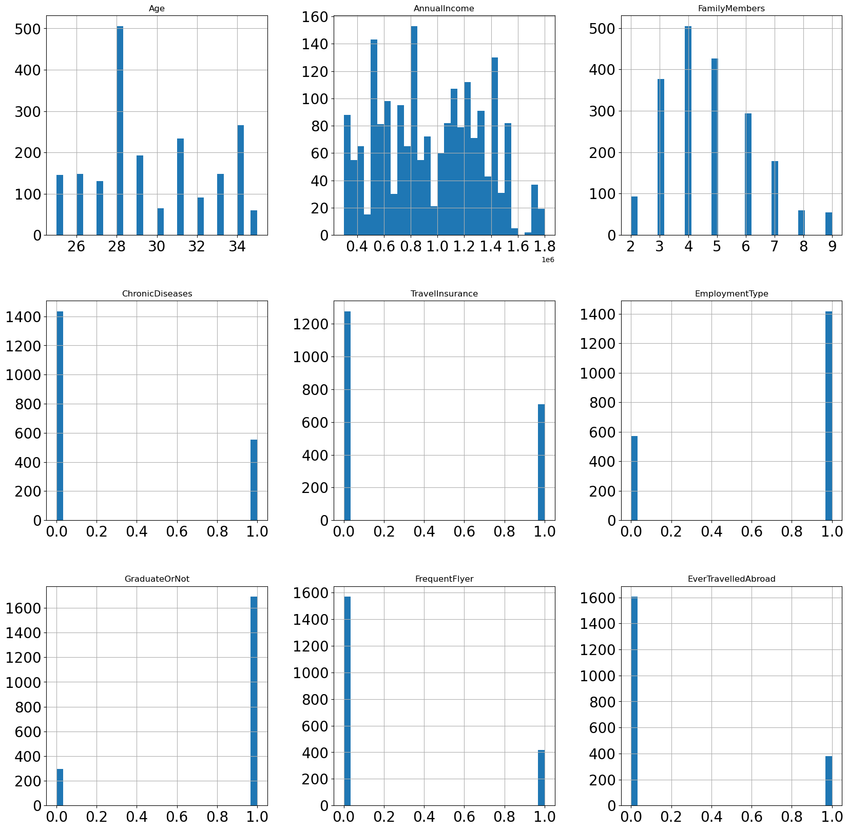

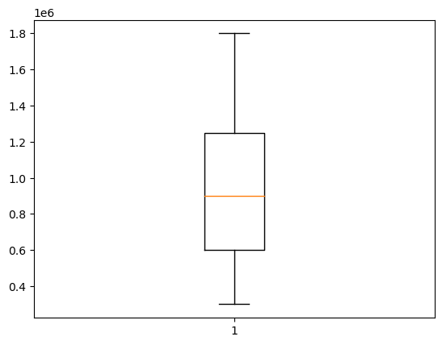

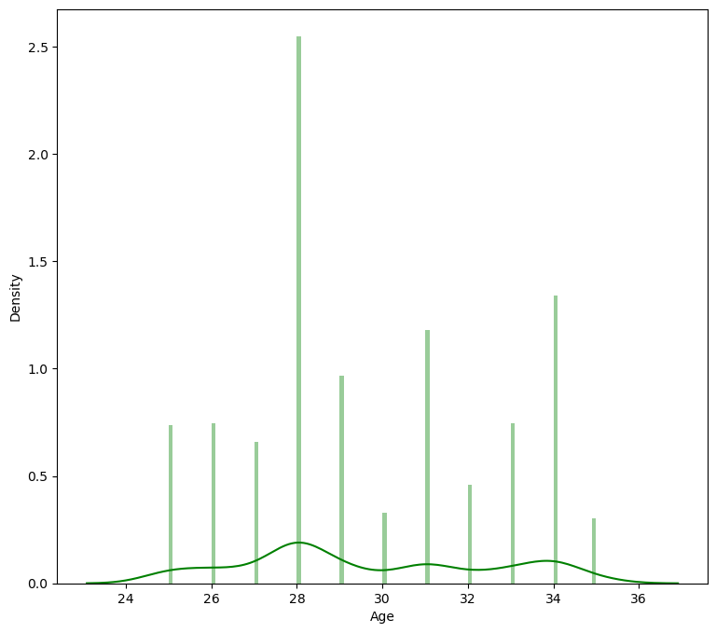

8. Applications

1. Risk Assessment: Predictive models help assess the risk associated with insuring travellers or specific trips. This includes evaluating factors like the traveller's age, destination, trip duration, and travel history to determine the likelihood of filing a claim.
2. Premium Pricing: Travel insurance prediction data is used to calculate premiums more accurately. It enables insurance providers to tailor premiums to individual travellers, resulting in personalized and competitive pricing.
3. Underwriting: Predictive analytics aids in the underwriting process by automating decisions regarding policy issuance and pricing. It streamlines the application and approval process for travellers.
4. Fraud Detection: Predictive models can identify suspicious patterns in claims data, which helps insurers detect and prevent fraudulent claims. This reduces the financial impact of insurance fraud
5. Claims Processing and Settlement: Predictive data can expedite the claims processing process by automating routine tasks and helping categorize claims for quicker review. It can also assist in assessing the validity of claims, leading to faster settlements.
6. Coverage Recommendations: Insurance providers can use predictive data to offer personalized coverage recommendations to travellers based on their travel plans, preferences, and risk factors, ensuring they have appropriate protection.
7. Trip Planning and Safety Alerts: Travel insurance companies can use predictive data to provide real-time safety alerts, travel advisories, and information about local healthcare facilities, enhancing traveller safety and overall experiences.

9 Future Scope

The future scope of travel insurance prediction data is promising, with several potential developments and applications on the horizon. Here are some key areas where travel insurance prediction data is expected to play a significant role in the future:

1. **Personalized Pricing and Coverage:** Travel insurance providers can use predictive data to offer more personalized pricing and coverage options. This means that individuals may receive policies tailored to their specific travel plans, health conditions, and risk profiles, potentially resulting in more cost-effective and suitable insurance packages.
2. **Risk Mitigation:** Insurance companies can use predictive data to better understand and mitigate risks. This can involve identifying high-risk destinations, weather-related events, or health risks and adjusting their coverage or premiums accordingly.
3. **Improved Customer Experience:** Predictive data can be used to enhance the customer experience. For example, insurance providers can use data to offer real-time travel advisories, safety tips, and claims processing, making it easier for travellers to stay informed and receive assistance when needed.
4. **Fraud Detection:** Predictive analytics can be employed to detect and prevent insurance fraud. By analyzing historical data and identifying patterns of fraudulent claims, insurers can reduce losses and maintain more affordable premiums.
5. **Data Integration:** Integrating travel insurance prediction data with other sources of information, such as booking platforms, travel agencies, and health records, can provide a more comprehensive view of travellers' risks and needs, leading to more accurate predictions and customized policies.
6. **Emerging Risks:** As new risks and challenges emerge in the travel industry, predictive data can adapt to identify and manage these risks effectively. For example, unforeseen events like natural disasters or public health crises can be factored into insurance models.

10 Bibliography

1. **Book: "Predictive Analytics for Dummies" by Anasse Bari, Mohamed Chaouchi, and Tommy Jung
   * This book covers the basics of predictive analytics and its applications in various industries, including insurance.
2. **Book: "Data Science for Business" by Foster Provost and Tom Fawcett
   * While not specific to travel insurance, this book provides a comprehensive overview of data science and its applications, which can be useful for understanding predictive analytics.
3. **"A Survey of Predictive Modelling in General Insurance" by David G. Dick, Harry H. Panjer, and Sheldon M. Ross
   * This paper offers insights into predictive modelling in the insurance industry, which can be relevant to travel insurance.
4. **"Machine Learning in Insurance with R" by Charles Givre
   * This book focuses on machine learning and predictive modelling within the insurance sector, which includes travel insurance.